Intro to Web Design Using Bootstrap

Exercise Book

REACH High - Spring 2016



Contents

Software Installation 1

Page Design 3

Exercise 1 – Your First Web Page 7

Exercise 2 – CSS and Page Content 9

Exercise 3 – Adding External Libraries 13

Exercise 4 – Bootstrap Grid System 15

Exercise 5 – Navbar and Footer 19

Exercise 6 - Basic Image Editing 23

Exercise 7 - Forms 29

Exercise 8 - Carousels 33

Exercise 9 – Animations 39

Final Exercise – Your Own Webpage 41

# Software Installation

You can use a PC or a Mac for this course – the same software is available for both.

You will use Google Chrome to preview the web pages you create.

1. Download the latest version of Google Chrome by going to https://www.google.com/chrome/browser/  
   and installing it.  
     
   Or, if you already have Google Chrome installed, ensure you have the latest version by going under the menu to “Help and About”, and then to “About Google Chrome.” Chrome will then ask you to update.  
   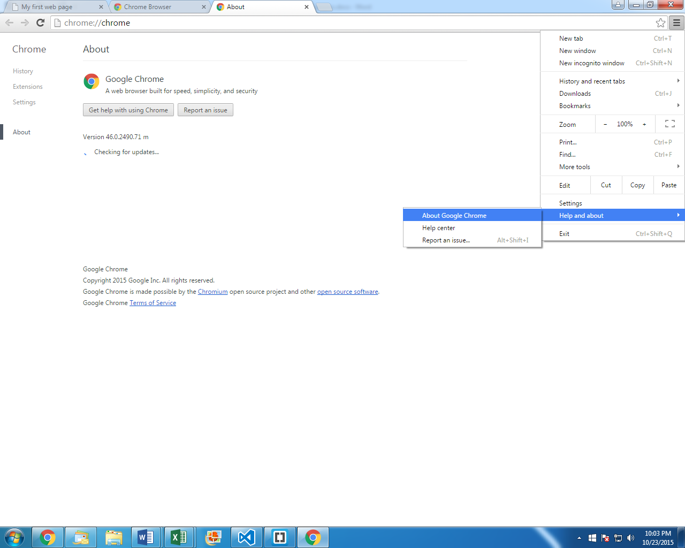

We will use a free program called *Brackets* for programming our web pages.

1. Download the latest version of Brackets by going to  
   http://brackets.io/  
   Choose to *Download Brackets without Extract*.  
   Once downloaded, install the program.

We will use a free program called *Pinta* for basic image editing.

1. Download the latest version of Pinta by going to  
   http://pinta-project.com/  
   Click on Download  
   Click on the Download link under Windows or Mac OS X.  
   Once downloaded, install the program.

# Page Design

In these exercises, we’ll be making a web site for a fictitious company named “Case Point” that makes phone cases. Here’s the design we’ve come up with – the grey boxes represent pictures or clip art that we’ll add.

Here’s the home page:

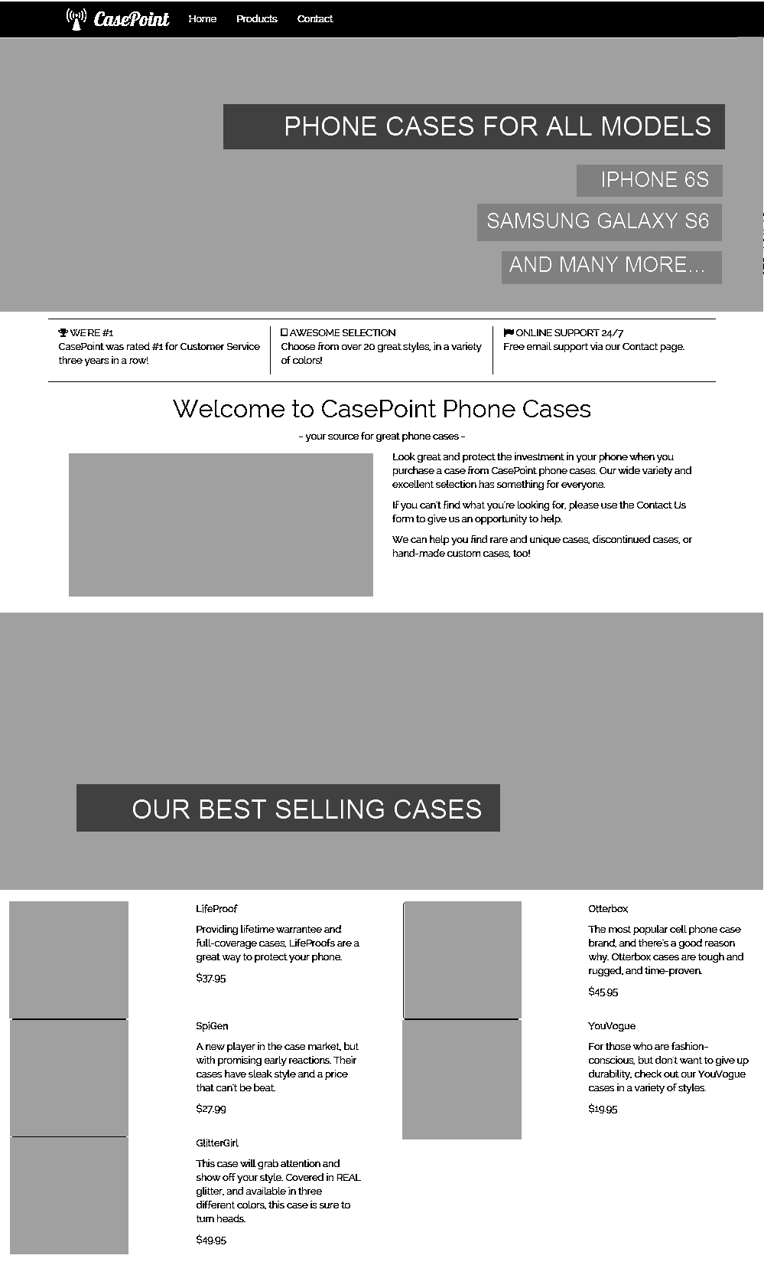

Here’s the “Products” page:

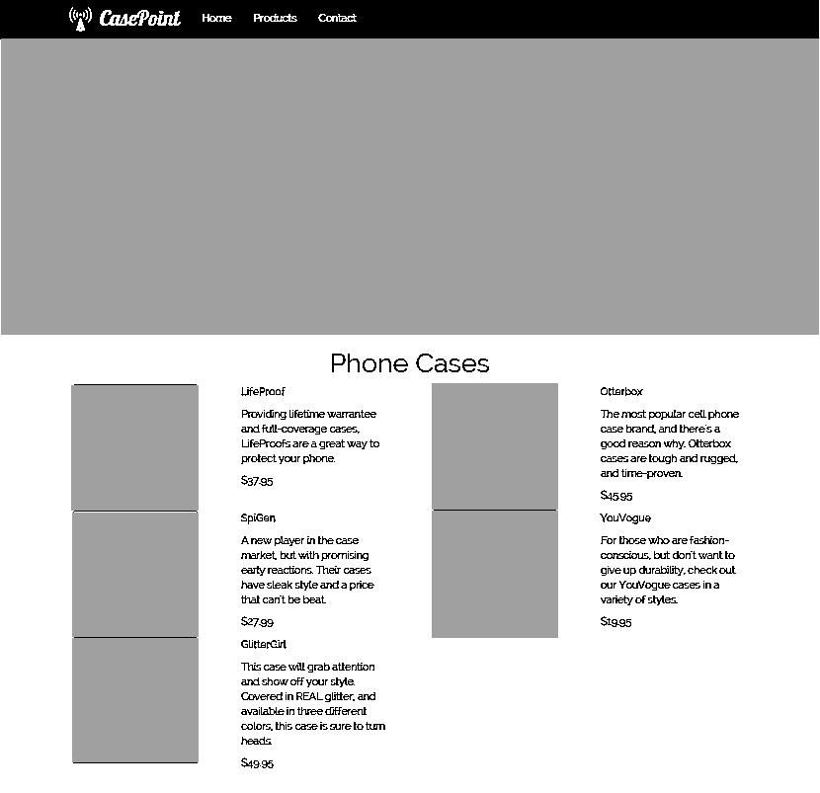

And finally, the “Contact” page:

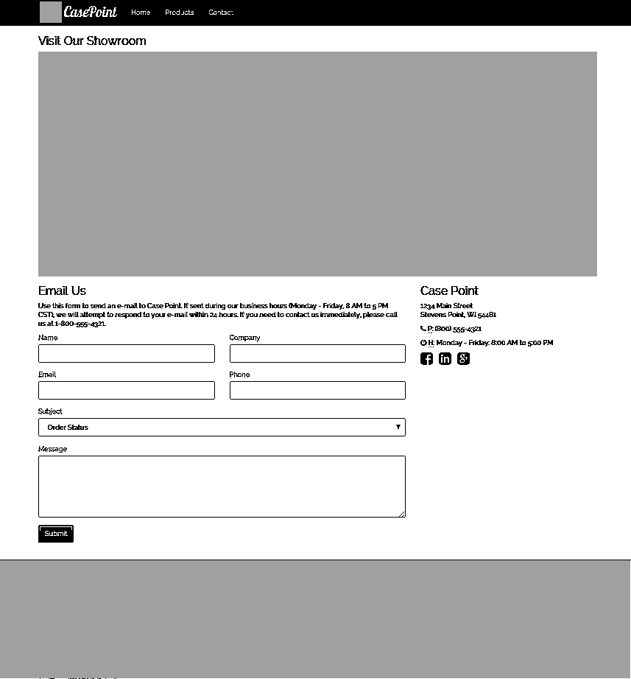

# Exercise 1 – Your First Web Page

1. Open Brackets.
2. Go under the File menu to Open Folder. Create a new folder in your documents called **Exercise1**, and then select that folder.
3. Go under the File menu to New.
4. Go under the File menu to Save. Name the new file **index.html**
5. Type the **DOCTYPE** element. This tells the browser we’re going to use the latest version of HTML.

<!DOCTYPE html>

1. Type the opening and closing tags for the **html** element.

<html></html>

Note that when you start typing the html element, Brackets gives you “Code Hints”. When the element you want is highlighted, just press Enter for Brackets to complete it for you.   
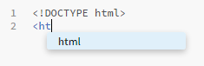  
Then, when you close the tag with a >, Brackets will automatically add the ending tag.  


1. Inside the html tag, add a **head** element. Inside the head element, add a **title** element. Inside the title element, type **Case Point Phone Cases**. The title will display on the tab in the browser.

<html>

<head>

<title>Case Point Phone Cases</title>

</head>

</html>

1. Between the </head> and </html> tags, add a body element. Inside the body element, add a **h1** element. Inside the h1 element, type **Case Point Phone Cases**.

...

</head>

<body>

<h1>Case Point Phone Cases</h1>

</body>

</html>

1. After the h1 element, add a **p** element. Inside the p element, add **- your source for great phone cases -**. The whole document should look like:

<!DOCTYPE html>

<html>

<head>

<title>Case Point Phone Cases</title>

</head>

<body>

<h1>Case Point Phone Cases</h1>

<p>- your source for great phone cases -</p>

</body>

</html>

1. Now, go under the File menu to **Live Preview**. Your first webpage will open in Chrome.
2. Add more to your first web page. The changes will show up in Chrome as you make them. Experiment with the different h tags: **h1, h2, h3, h4, h5, h6**. What is the difference between them?

_________________________________________________________________

1. Make sure you Save All before exiting Brackets.

# Exercise 2 – CSS and Page Content

1. Copy your **Exercise1** folder to a new folder called **Exercise2**.
2. Open Brackets.
3. Go under the File menu to Open Folder. Choose the **Exercise2** folder.

## Add Styles To Your Page

1. Go under the File menu to New.
2. Go under the File menu to Save. Create a new folder in the Exercise2 folder called **css**. Save the new file in the css folder, and call it **site.css**.
3. In the new file, add two new classes:

.title {

text-align: center;

}

.green {

color: #73a839;

}

1. Open the index.html file.
2. After the <title>, but before the </head> tag, add a link to the new css file:

<link rel="stylesheet" href="css/site.css">

1. Add a **<div>** element around the existing h1 and p tags.
2. Add the **title** class to the **<div>** tag.
3. Add the **green** class to the **<p>** tag.
4. Go under the File menu to **Live Preview**. Make sure that the text is centered, and the subtitle is green.

## Add More Text To Your Page

1. In the Resources file that you were sent, open the **content** folder, and open the **Home Page.txt** file.
2. There’s two halves to the **Home Page** file. The first half has three “tag lines” and descriptions. The second half has three paragraphs of text. Copy the first half into index.html before the <div>.
3. Copy the second half of the **Home Page** file after the </div>.
4. Put a **<div>** element around each of the three taglines, and a **<p>** element around the description. For example, the first one would look like:

<div>

WE'RE #1

<p>CasePoint was rated #1 for Customer Service three years in a row!</p>

</div>

1. Put one **<div>** element around the three paragraphs of information, and put a **<p>** element around each paragraph.

## Add the Products Page

1. Go under the File menu to New.
2. Go under the File menu to Save. Name the new file **products.html**
3. Copy all the HTML from index.html into products.html.
4. In products.html, change the content of the h1 element to say **Phone Cases**, and delete the tagline paragraph.
5. Delete the **<div>**s besides the one with a **title** class.
6. Change the Title of the page to **Case Point Phone Cases – Products**.
7. In the Resources file that you were sent, copy the **images** folder into your **Exercise 2** folder.
8. In the Resources file that you were sent, open the **content** folder, and open the **Products.txt** file.
9. Copy the contents of the text file into products.html after the </div>.
10. Format all five items following this example:

<div>

<img src="images/lifeproof.jpg">

</div>

<div>

<p><strong>LifeProof</strong></p>

<p>Providing lifetime warrantee and full-coverage cases, LifeProofs are a great way to protect your phone.</p>

<p>$37.95</p>

</div>

1. Go under the File menu to **Live Preview**, or click on the **Lightning Bolt**. Don’t worry that the page looks dull. We’ll make it look better in the coming weeks.

## Add the Contact Page

1. Go under the File menu to New.
2. Go under the File menu to Save. Name the new file **contact.html**
3. Copy all the HTML from index.html into contact.html.
4. Change the Title of the page to **Case Point Phone Cases – Contact Us**.
5. In contact.html, change the content of the h1 element to say **Email Us**. Then change the **<h1>** tags to be **<h3>**.
6. Delete the **green** class from the paragraph after the **h3** tags.
7. In the Resources file that you were sent, open the **content** folder, and open the **Contact.txt** file. Copy the first line of the contents of the text file into the **p** element.
8. Delete the **<div>**s besides the one with a **title** class.
9. From the **Contact.txt** file, copy the name/address after the **</div>** tag and format it like this:

<div>

<h3>Case Point</h3>

<p>

1234 Main Street<br>

Stevens Point, WI 54481

</p>

</div>

## Add Navigation

1. In the **contact.html** page, after the **<body>** tag (but before the title **div**) add a **<div id="navlinks">**.
2. Within the **<div>**, add a **<ul>**.
3. Within the **<ul>**, add three **<li>** elements.
4. Within each **<li>**, add a **<a href=""></a>** element, linking to index.html, products.html, and contact.html. Label the links Home, Products, and Contact.
5. Copy this new **<div>** into the **index.html** and **products.html** page in the same place.
6. View your site, and test the links to make sure they navigate between your three pages.

# Exercise 3 – Adding External Libraries

1. Copy your **Exercise2** folder to a new folder called **Exercise3**.

## Download Bootstrap

1. Go to <http://getbootstrap.com/>
2. Click on the large **Download Bootstrap** button, then click on the **Download Bootstrap** button.
3. Extract the zip file, and copy the **css**, **fonts**, and **js** folders into your **Exercise3** folder. Merge the folders with the existing folders.

## Download Custom Bootstrap Theme

1. Go to <https://bootswatch.com/>
2. Find the **Cerulean** theme, and click the **Download** button.
3. Right-click (Ctrl+Click on a Mac) on the text that appears, and go to **Save As**. Save the file in your **Exercise3** folder, inside the **css** folder. Overwrite the existing **bootstrap.min.css**.

## Download Font Awesome

1. Go to <https://fortawesome.github.io/Font-Awesome/>
2. Click the **Download** button. Click the **Download** button.
3. Extract the zip file, and copy just the **css** and **fonts** folders into your **Exercise3** folder. Merge the folders with the existing folders.

## Download JQuery

1. Go to <https://jquery.com/>
2. Click the **Download JQuery** button.
3. Under jQuery 2.x, click the **Download the compressed, production jQuery 2.1.4** link.
4. Copy the downloaded file into the **Exercise3** folder, inside the **js** folder.

## Add Bootstrap, JQuery and Font Awesome To Your Pages

1. Open Brackets.
2. Go under the File menu to Open Folder. Choose the **Exercise3** folder.
3. Open the **index.html** file.
4. Right before the existing **<link>** element, add the following:

<link rel="stylesheet" href="css/bootstrap.min.css">

<link rel="stylesheet" href="css/font-awesome.min.css">

1. At the end of your web page, right before the **</body>** tag, add the following:

<script src="js/jquery-2.1.4.min.js"></script>

<script src="js/bootstrap.min.js"></script>

1. Repeat steps 18 and 19 for **contact.html** and **products.html**.
2. Preview your pages (using the Lightning Bolt). You should notice that the fonts look different.

## Add Bootstrap Container

1. Open **index.html**. After the **</div>** tag for the **<div>** element with id of **navlinks**, add a **div** that will contain the main page content. Adding a **<div>** with a class of **container** is used to add margins and format the main page content.

<div class="container">

1. Add the **</div>** near the bottom of the page, right above the first **<script>** tag.
2. Directly after the **<head>** tag, add the following:

<meta charset="utf-8">

<meta http-equiv="X-UA-Compatible" content="IE=edge">

<meta name="viewport" content="width=device-width, initial-scale=1">

This is some metadata that tells the browser how to render your page, and will be necessary for making your page display correctly on a mobile device.

1. Repeat steps 22 through 24 for the **contact.html** and **products.html**.

## Change Fonts

1. Go to https://www.google .com/fonts
2. Use the search box in the upper left to search for **Lobster**. Click the “Quick Use” button.  
   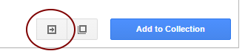
3. Scroll down to step 3, and click on the **@import** tab.Copy the text, and add it to the very top of the **site.css** file.
4. Repeat the previous two steps for the font **Raleway**.
5. Add the following style to the **site.css** file

body, h1, h2, h3, h4, h5, h6 {

font-family: 'Raleway', sans-serif;

}

.navbar-brand {

font-family: 'Lobster';cursive;

font-size:2em;

}

1. Preview your web pages. The fonts look nicer now!

# Exercise 4 – Bootstrap Grid System

1. Copy your **Exercise3** folder to a new folder called **Exercise4**.
2. Open Brackets.
3. Go under the File menu to Open Folder. Choose the **Exercise4** folder.

## Apply Grid System to Products Page

1. Open **products.html.**
2. Add a

<div class="row">

right after the **</div>**  tag for the **div** element with a class of **title**. Add a

</div>

near the end of the document, right before the **<script>** element. Putting items in a **row** allows them to appear side-by-side, instead of just one on top of each other – but first we need to specify how we want the columns to appear.

1. So that the products will display side-by-side, add a **<div class="col-sm-6">** and the corresponding **</div>** around each product group, so each one looks like:

<div class="col-sm-6">

<div>

<img src="images/lifeproof.jpg">

</div>

<div>

<p><strong>LifeProof</strong></p>

<p>Providing lifetime warrantee and full-coverage cases, LifeProofs are a great way to protect your phone.</p>

<p>$37.95</p>

</div>

</div>

Remember, the **col-sm-6** means that the div will take up 6 of the 12 columns on the screen *unless* the screen is very small (phone screen).

1. Preview your page. Resize/zoom the browser window to see how the column layout adjusts to the screen size!
2. Add **class="img-thumbnail"** to each of the **img** tags on the page. This will put a nice border around the images and size the consistently.
3. We’d like to have the thumbnail images display side-by-side with the description. Add a **class="col-sm-6"** to all the **<div>** tags containing the images, and all the **<div>** tags containing the descriptions.
4. Preview your page. This looks good for full screen. But resize your window to be narrow, and the images stack on top of the descriptions again, and don’t look very good.
5. Let’s add classes so when we’re on a phone-sized screen, the images take up 3 columns, and the description takes up 9 columns. Add a **col-xs-3** class to all the **<div>** tags containing the images, and add a **col-xs-9** class to all the **<div>** tags containing the descriptions.
6. Preview your page. At really small sizes, it looks good, and at full screen size, it looks good, but there’s a size in-between (around 600 pixels wide) where the way the columns wrap gets goofy. To fix this, add

<div class="clearfix"></div>

After the **</div>** tag of each **<div>** containing the product information.

1. Let’s tweak our columns once more, for large screens. Let’s make it so on large screens the image takes up 3 columns, and the description takes up 9 columns. What class should we add to the **<div>** tag containing the images?

________________________________________________________________________

What class should we add to the **<div>** tag containing the description?  
  
________________________________________________________________________

## Apply Grid System to Home Page Info Bar

1. Open **index.html**
2. Find the three **<div>**s with “WE’RE #1”, “AWESOME SELECTION”, and “ONLINE SUPPORT 24/7” text. We want these three taglines to be on a single line, so we need to surround them with a row. Add a **<div class="row info-bar">** and **</div>** around the group of three. We’ve added the info-bar class so we can do some additional styling.
3. Add a **class="col-sm-4"** to each of the three **<div**>s.
4. Let’s add some icons to these three taglines. Go to <https://fortawesome.github.io/Font-Awesome/>.
5. Click on the Icons menu at the top.
6. Find and click on the **trophy** icon.
7. Copy the HTML example for the trophy icon, and paste it into **index.html** right before the **WE’RE #1**.
8. Find the **tablet** icon and put it in front of **AWESOME SELECTION**.
9. Find the **flag** icon and put it in front of **ONLINE SUPPORT 24/7**.
10. Preview your page. It’s looking pretty good, but there’s a little styling we can add. Add the following to your **site.css**, to add some margin, padding, and borders to the info-bar.

.info-bar {

margin-top:10px;

padding-top:10px;

padding-bottom:10px;

border-top: 1px solid rgba(0,0,0,.1);

border-bottom: 1px solid rgba(0,0,0,.1);

}

.info-bar div {

border-right: 1px solid rgba(0,0,0,.1);

}

.info-bar div:last-child {

border-right: 0px;

}

1. Add a **<span**> element around the text **WE’RE #1**. Add a **<span**> element around the text AWESOME SELECTION. Add a **<span**> element around the text ONLINE SUPPORT 24/7. This will allow us to apply styles just to these taglines.
2. Add the following styles to your **site.css**:

.info-bar span, .info-bar i {

font-size: 1.5em;

}

1. This looks great, but this info bar is just extra fluff that we don’t need to show when someone views the page on a phone. What class would we add to the **info-bar** **<div>** so that its hidden for extra-small screens? (Hint: see http://getbootstrap.com/css/#responsive-utilities-classes)  
     
   _______________________________________________________________

## Add image to home page

1. Let’s add an image to the home page, near the paragraphs of text. Before the **<div>** that contains the three paragraphs, add a new **<div>** and image:

<div>

<img src="images/5-cases.jpg" class="img-responsive">

</div>

1. Add another **<div>** element to surround the image and paragraphs.
2. Preview your page.

## Exercise 4 Challenge

1. We want to display the “5 cases” picture and the paragraphs side-by-side, so each takes up half the page width – except when at extra small resolutions like on a phone. See if you can figure out how to do it. You’ll need to add a certain CSS class to each of the three **<div>** elements.  
     
   CSS class added to the outer **<div>**:__________________________________________  
     
   CSS class added to the **<div>** around the **<img>**: ________________________________  
     
   CSS class added to the **<div>** around the **<img>**: _________________________________

# Exercise 5 – Navbar and Footer

## Add Bootstrap Navbar

1. Copy your Exercise4 folder to a new folder called Exercise5.
2. Open Brackets.
3. Go under the File menu to Open Folder. Choose the **Exercise5** folder.
4. Go to <http://getbootstrap.com/>, and click on **Getting Started**. Then click on **Examples** in the right column. Click on the first example, **Starter Template**.
5. Right click (or Ctrl-Click on a Mac) in the whitespace of the example page, and go to **View Page Source**.
6. Find the **<nav>** element – copy it and everything in it.
7. In **index.html**, paste it directly after the **<body>** tag.
8. Notice the **<div>** with the id of **navbar**. It looks very similar to the navigational links we created in exercise 2 (in the **<div>** with an id of **navlinks** – which should be just under the **</nav>** tag). Update the **<a>** elements within the **navbar** **<div**>so they match the links for our site.
9. Ensure the **<li>** that contains the link to the home page has a **class="active"** attribute.
10. Delete the **navlinks <div>.**
11. Find the **<a>** with a class of **navbar-brand**. Change the **href** attribute to **index.html**, and change the text inside the element to say **CasePoint**.
12. Before that **<a>** element, add:

<a href="index.html" class="pull-left"><img class="logo" src="images/logo.png"></a>

1. Open **site.css**, and add the following styles:

body {

padding-top: 50px;

}

1. Preview your page (using the Lightning Bolt). Shrink or zoom your web browser to make it narrower, so that the mobile navigation appears. Make sure that the mobile navigation bar works.
2. If everything works, copy the **<nav>** element and everything in it onto the **contact.html** and **products.html** pages, replacing the existing **<div>** with id **navlinks**.

## Add Footer

1. Open **index.html**.
2. Before the **<script>** tags, add the following HTML for a footer:

<footer>

<div class="container">

<div class="row">

<div class="col-md-4">

<!-- COLUMN 1 -->

<h3>ABOUT</h3>

<p>We were formed out of a desire to provide clarity in the world of confusion around cell phone cases. The market has been flooded with many low quality knock-off cases that provide sub-par protection for your device. We only sell products that we stand behind.</p>

<br>

<address>

<ul class="list-unstyled">

<li>1234 Main Street<br> Stevens Point, WI 54481</li>

<li>Phone: (1800) 555 - 4321</li>

<li>Email: info@casepoint.com</li>

</ul>

</address>

<!-- END COLUMN 1 -->

</div>

<div class="col-md-4">

<!-- COLUMN 2 -->

<h3>LINKS</h3>

<div class="row">

<div class="col-xs-6">

<div>

<ul class="list-unstyled">

<li><a href="index.html">Home</a></li>

<li><a href="products.html">Products</a></li>

<li><a href="contact.html">Contact Us</a></li>

</ul>

</div>

</div>

<div class="col-xs-6">

<div>

<ul class="list-unstyled">

<li><a href="http://maps.google.com" target="_blank">Get Directions to Us</a></li>

<li><a href="http://plus.google.com" target="_blank">View our Page on Google+</a></li>

<li><a href="http://www.mobilefun.com/blog/" target="_blank">Mobile Fun Blog</a></li>

</ul>

</div>

</div>

</div>

<h3>GET CONNECTED</h3>

<div>

<ul class="list-inline">

<li><a href="//facebook.com"><i class="fa fa-facebook"></i></a></li>

<li><a href="//linkedin.com"><i class="fa fa-linkedin"></i></a></li>

<li><a href="//dribbble.com"><i class="fa fa-dribbble"></i></a></li>

<li><a href="//instagram.com"><i class="fa fa-instagram"></i></a></li>

<li><a href="//plus.google.com"><i class="fa fa-google"></i></a></li>

</ul>

</div>

<!-- END COLUMN 2 -->

</div>

<div class="col-md-4">

<!-- COLUMN 3 -->

<div>

<h3>NEWSLETTER</h3>

<p>Get the latest update from us by subscribing to our newsletter.</p>

<form method="POST">

<div class="input-group input-group-lg">

<input type="email" class="form-control" id="email" placeholder="youremail@domain.com">

<span class="input-group-btn">

<button class="btn btn-primary" type="button" id="btn-subscribe-newsletter">

<span>SUBSCRIBE</span>

</button>

</span>

</div>

</form>

</div>

<!-- END COLUMN 3 -->

</div>

</div>

</div>

<!-- COPYRIGHT -->

<div class="text-center copyright">© Case Point 2016. All rights reserved.</div>

<!-- END COPYRIGHT -->

</footer>

1. Copy the **<footer>** element and everything in it onto the **contact.html** and **products.html**.
2. Open **site.css**. Add a style to format the footer:

footer {

background-color: #49494b;

color: #ffffff;

margin-top: 20px;

}

## Add JavaScript for Footer

1. Open **index.**html.
2. After the last **</script>** tag, add the following custom JavaScript to make the newsletter sign-up in the footer work:

<script>

$(function() {

$("#btn-subscribe-newsletter").click(function() {

var email=$("#email").val();

window.location.href='mailto:newsletter@casepoint.com?subject=Newsletter Subscribe&body=Please subscribe ' + email + ' to your newsletter.';

});

});

</script>

1. Copy the custom script onto **contact.html** and **products.html** in the same spot.

## Exercise 5 Challenge

1. Preview your pages, and navigate between them. What’s not quite right with our header? (Hint: It’s easier to see what’s wrong on the non-mobile view.)

_________________________________________________________________

1. Try to fix what’s wrong. What did you need to change?   
     
   _________________________________________________________________

# Exercise 6 - Basic Image Editing

1. Copy your **Exercise5** folder to a new folder called **Exercise6**.
2. Open Brackets.
3. Go under the **File** menu to **Open Folder**. Choose the **Exercise6** folder.

## Add Triangle Phone image to home page

1. Open the **Pinta** application for image editing.
2. Open the girl-with-triangle-phone-case-original.jpg file from the **Exercise6\images** folder. The image is currently 600 x 337 pixels. Our goal is to get the image to be 1200 x 400 pixels.

Original:   
Goal: 

1. The first step is to resize the image to the largest dimension (the width, in this case).
   1. Go under the **Image** menu to **Resize Image**.
   2. Choose **By absolute size:**
   3. Specify 1200 pixels wide.
   4. The height will automatically adjust because the **Maintain aspect ratio** box is checked. 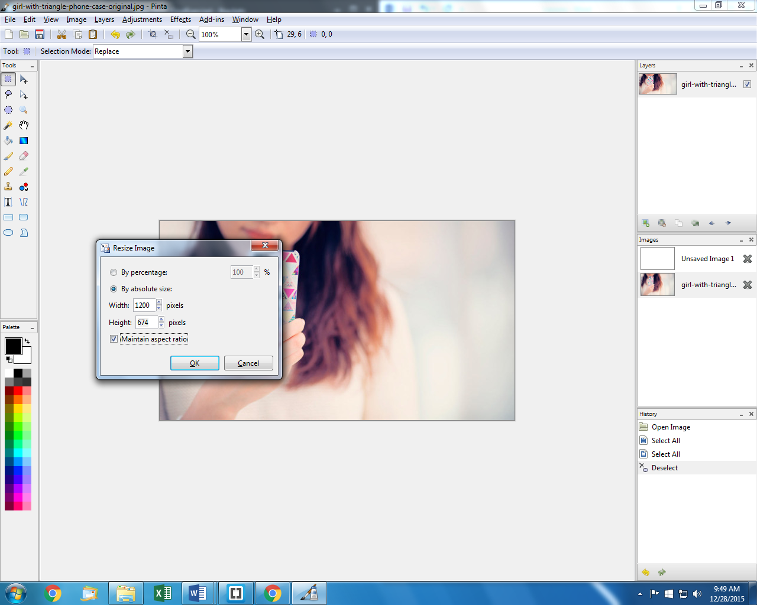
   5. Hit OK.
2. The next step is to crop the image to the other dimension (the height, in this case).
   1. Go under the **Image** menu to **Resize Canvas**.
   2. Choose **By absolute size**.
   3. Uncheck the **Maintain aspect ratio** box.
   4. Change the height to 400.
   5. Click on the button in the center top, since we don’t want to crop off any more of the girl’s face.  
      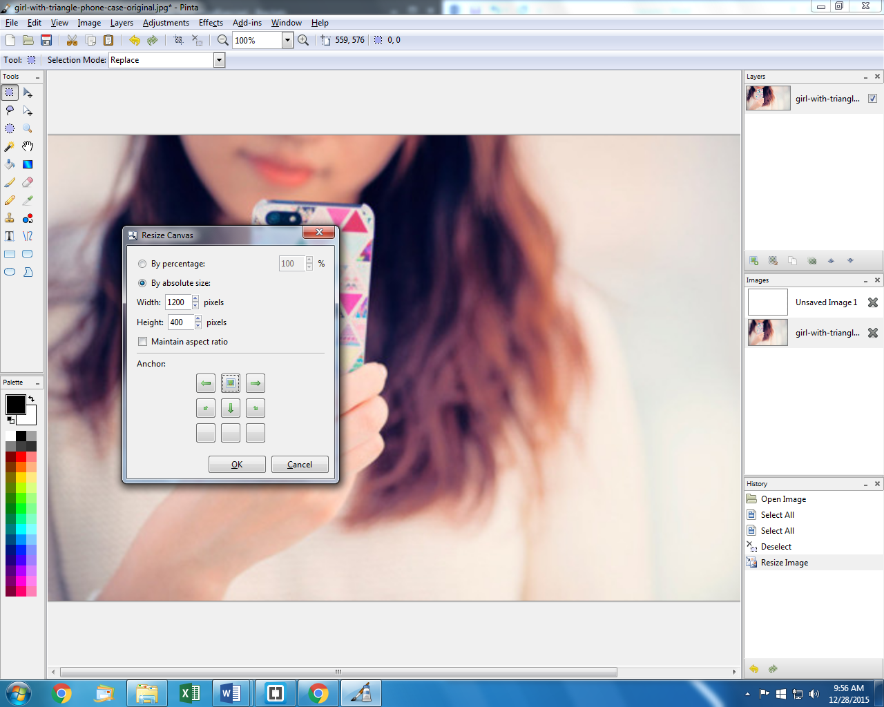
   6. Hit OK
3. Go under the **File** menu to **Save As**. Save the image as **girl-with-triangle-phone-case-resized.jpg** in the **images** folder in your Exercise6 folder. Save with a quality of 90.
4. In **Brackets,** open **Index.html**. Right before the **<footer>** element, add an **<img>** element to display the resized image. Add a **class="full-width"** attribute to the **<img>**.
5. Open **site.css**. Add the following section:

.full-width {

min-width: 100%;

}

1. Preview the page, and resize the browser to test different widths. Because of the full-width class we added, the image fills the width of the page. But does it shrink down when the browser window shrinks? If not, there’s a certain Bootstrap class you’ll need to add to the **<img>** element.   
     
   What class needs to be added? ______________________________________  
   *Hint:* Check out http://getbootstrap.com/css/#images

## Add Talking on Phone image to home page

1. In Pinta, open the **talking-on-phone-original.jpg** file from the **Exercise6\images** folder. The image is currently 2000 x 1000 pixels. Our goal is to get the image to be 1200 x 400 pixels.
2. Use the steps from the previous section to resize and crop the image to the size we need.
3. Save the image as **talking-on-phone-resized.jpg** into the **Exercise6\images** folder. Save with a quality of 90.
4. In Brackets, directly after the **</nav>** tag, add an **<img>** element to display the resized image. Ensure you add both classes to make it resize responsively and fill the width of the browser.
5. Preview the page and make sure the image is displaying properly.

## Add Man on Phone image to Products page

1. In Pinta, open the **man-on-phone-original.jpg** file from the **Exercise6\images** folder. The image is currently 2800 x 1867 pixels. Our goal is to get the image to be 1200 x 400 pixels.
2. Use the steps from the previous section to resize and crop the image to the size we need.
3. Save the image as **man-on-phone-resized.jpg** into the **Exercise6\images** folder. Save with a quality of 90.
4. Open the **products.html** page.
5. In Brackets, directly after the **</nav>** tag, add an **<img>** element to display the resized image. Ensure you add both classes to make it resize responsively and fill the width of the browser.
6. Preview the page and make sure the image is displaying properly.

## Resize Shattered IPhone image

1. In Pinta, open the **shattered-phone-screen-original.jpg** file from the **Exercise6\images** folder. The image is currently 1200 x 800 pixels. Our goal is to get the image to be 1200 x 400 pixels. *However*, this time we don’t want to crop any of the image away. Instead, we want to just add white space to the image to make it the right size.  
   Original: 

Goal: 

1. The first step is to resize the image to the shortest dimension (the height, in this case).
   1. Go under the **Image** menu to **Resize Image**.
   2. Choose **By absolute size:**
   3. Specify 400 pixels high.
   4. The width will automatically adjust because the **Maintain aspect ratio** box is checked.
   5. Hit OK.
2. The next step is to add canvas size to the other dimension (the width, in this case).
   1. Go under the **Image** menu to **Resize Canvas**.
   2. Choose **By absolute size**.
   3. Uncheck the **Maintain aspect ratio** box.
   4. Change the width to 1200.
   5. Click on the button in the center left, since we want to leave the iPhone on the left of the image, and just add space to the right.  
      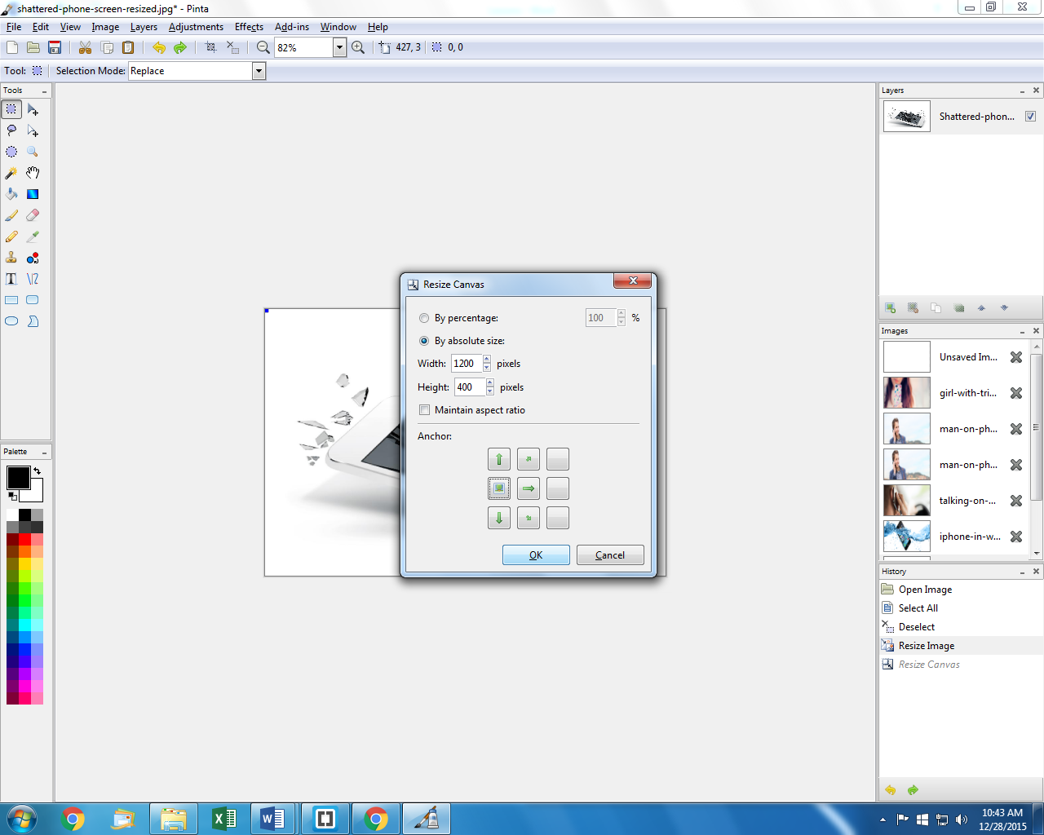
   6. Hit OK
3. In the Tools window, click on the Paint Bucket tool.  
   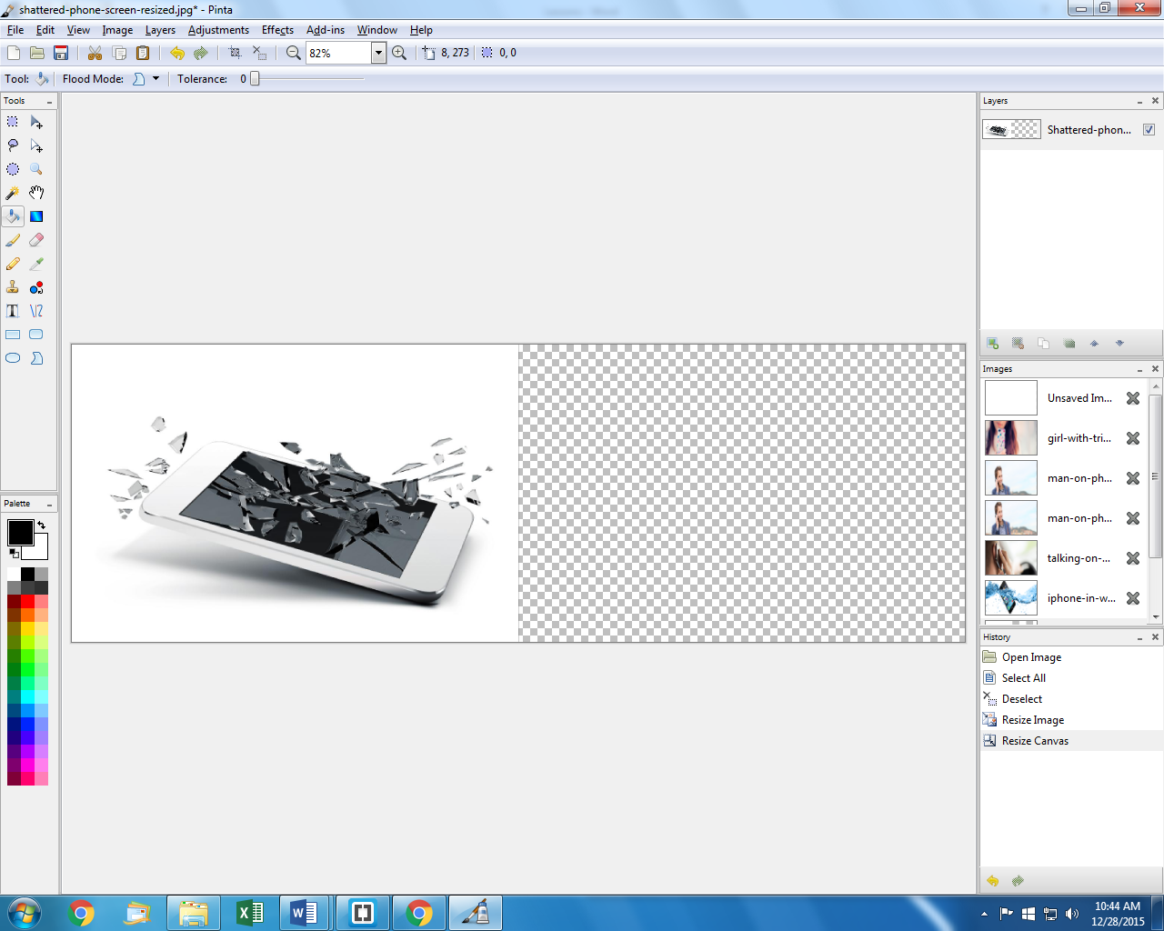
4. In the Palette window, click on the white color to choose the foreground color.  
   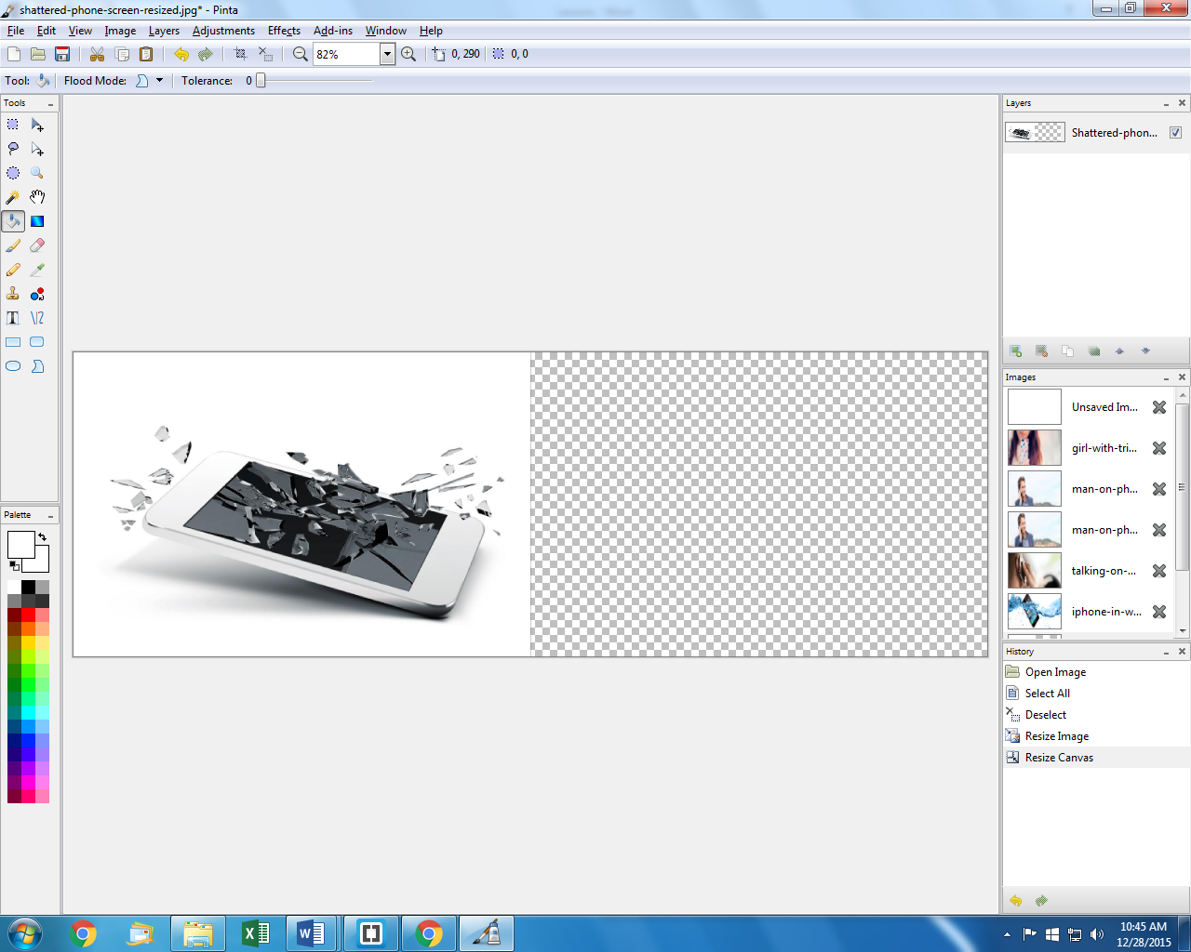
5. Click in the hatched area of the image, to fill it with white.
6. Save the image as **shattered-phone-screen-resized.jpg** into the **Exercise6\images** folder. Save with a quality of 90. We don’t need to put it on a page for now – we’ll use it in a future lesson.

## Exercise 6 Challenge

1. In Pinta, open the **iphone-in-water-original.png** file from the **Exercise6\images** folder. The image is currently 1600 x 561 pixels. Our goal is to get the image to be 1200 x 400 pixels.   
   Original: 

Goal: 

1. Crop and resize the image as necessary. Save the image as **iphone-in-water-resized.jpg** into the **Exercise6\images** folder. Save with a quality of 90. We don’t need to put it on a page for now – we’ll use it in a future lesson.

# Exercise 7 - Forms

1. Copy your **Exercise6** folder to a new folder called **Exercise7**.
2. Open Brackets.
3. Go under the **File** menu to **Open Folder**. Choose the **Exercise7** folder.
4. Open the **contact.html** page. We’ll be filling in the content on this page to match our design sketch. The large gray box at the top of the page will have a Google Map of our location.  
   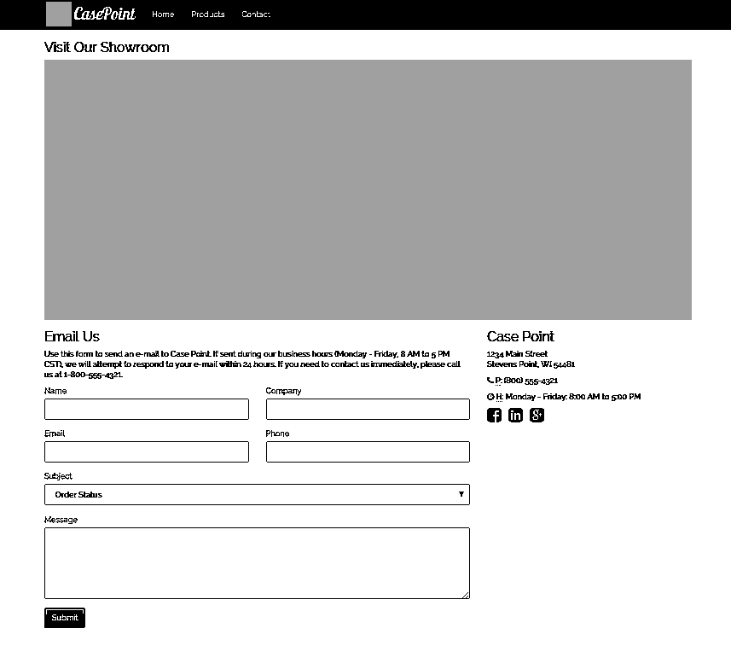

## Add the Email Us Form

1. We’ll start with the form. We first need to define a Bootstrap row to be able to put the Email Us form and the Case Point address side-by-side.  
   Right after the **<div class="container">**, add

<div class="row">

1. Add the **</div>** tag before the **<footer>** tag.
2. On the **<div class="title">**, remove the **title** class, and add a **col-sm-8** class.
3. On the **<div>** surrounding the address, add a **col-sm-4** class.
4. Preview the page. Now the Email Us and Case Point address info appear side-by-side.
5. After the 1-800 number and the **</p>** tag, add a form, and immediately add a **<div class="row">**:

<form method="post" action="mailto:info@casepoint.com?subject=Web Site Email" enctype="text/plain">

<div class="row">

</div>

</form>

1. Add the Name, Company, Email, and Phone fields inside the **<div class="row">**. For example, here’s how the Name field should look:

<div class="form-group col-lg-6">

<label for="fullname">Name</label>

<input type="text" name="fullname" class="form-control">

</div>

1. Using **type="text"** gives a generic text box. But there are special types available for things like phone numbers, email addresses, date, time, etc. Refer to the class slides to find the list of possibilities, and then use them for the Email and Phone fields.
2. For the Subject field, create a **<div>** and **<label>** like you did for the text boxes, but instead of an **<input>,** we’ll use a **<select>**:

<select name="subject" class="form-control">

<option>Order Status</option>

<option>Billing Question</option>

<option>General Information</option>

<option>Web Site Comment/Problem</option>

<option>Employment</option>

<option>Other</option>

</select>

1. For the Message field, create a **<div>** and **<label>** like you did for the text boxes, but instead of an **<input>,** we’ll use a **<textarea>**:

<textarea name="message" class="form-control" rows="6"></textarea>

1. To add the button at the bottom of the form, create a **<div>** like you did for the text boxes, but add the button inside it:

<button type="submit" class="btn btn-primary">Submit</button>

1. Change the class on the **<div>**s that surround the subject and message fields, and the button, to have a class of **col-lg-12** so that they always take up the full width.
2. Preview your page. Make sure the form appears correctly.

## Completing the Contact Info

1. In the **<div>** surrounding the address, right before the **</div>** tag, add the following to complete the contact information:

<p>

<i class="fa fa-phone"></i>

<abbr title="Phone">P</abbr>: (800) 555-4321

</p>

<p>

<i class="fa fa-clock-o"></i>

<abbr title="Hours">H</abbr>: M - F: 8:00 AM to 5:00 PM

</p>

<ul class="list-unstyled list-inline">

<li>

<a href="https://www.facebook.com/casepoint" title="Facebook"><i class="fa fa-facebook-square fa-2x"></i></a>

</li>

<li>

<a href="https://www.linkedin.com/company/casepoint" title="LinkedIn"><i class="fa fa-linkedin-square fa-2x"></i></a>

</li>

<li>

<a href="https://www.google.com/+CasePoint" title="Google+"><i class="fa fa-google-plus-square fa-2x"></i></a>

</li>

</ul>

## Adding the Map

Now we want to add a map to the page, so people can see where the store is at. First, let’s make a place in the page for it to appear.

1. Find the **<div class="container">** tag at the top of the page. Immediately after the opening tag, insert a new row, with a <div> that takes up all 12 columns:

<div class="row">

<div class="col-lg-12">

<h3>Visit Our Showroom</h3>

</div>

</div>

1. Go to <http://maps.google.com>
2. Search for 1234 main street, Stevens Point, WI
3. Once the location appears, click on the Share button.  
   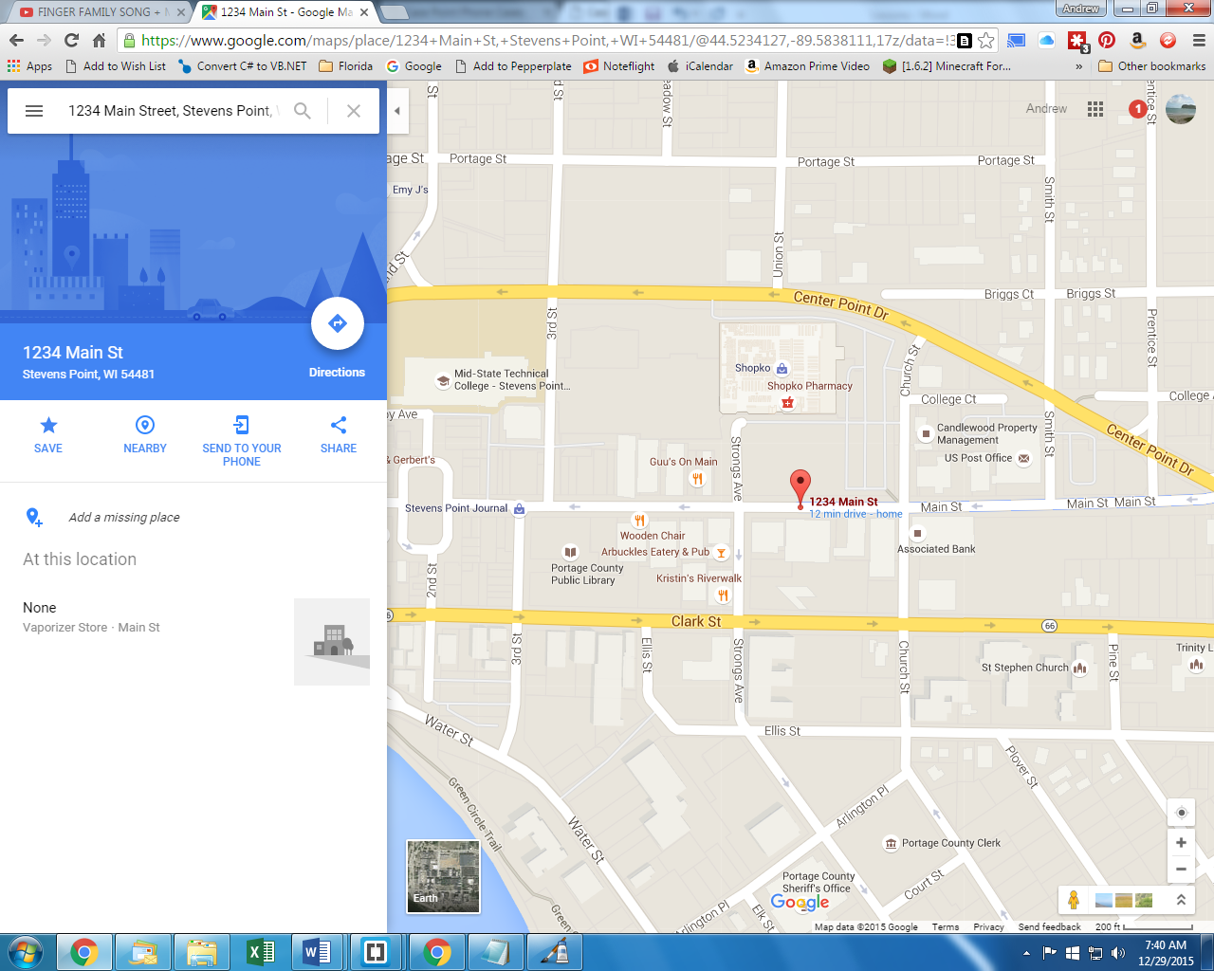
4. In the window that appears, click on **Embed Map**.
5. A drop-down will show Medium – change it to **Custom Size**.
6. Enter **1200** x **450**.
7. Copy the HTML (an **<iframe>** element) in the textbox.  
   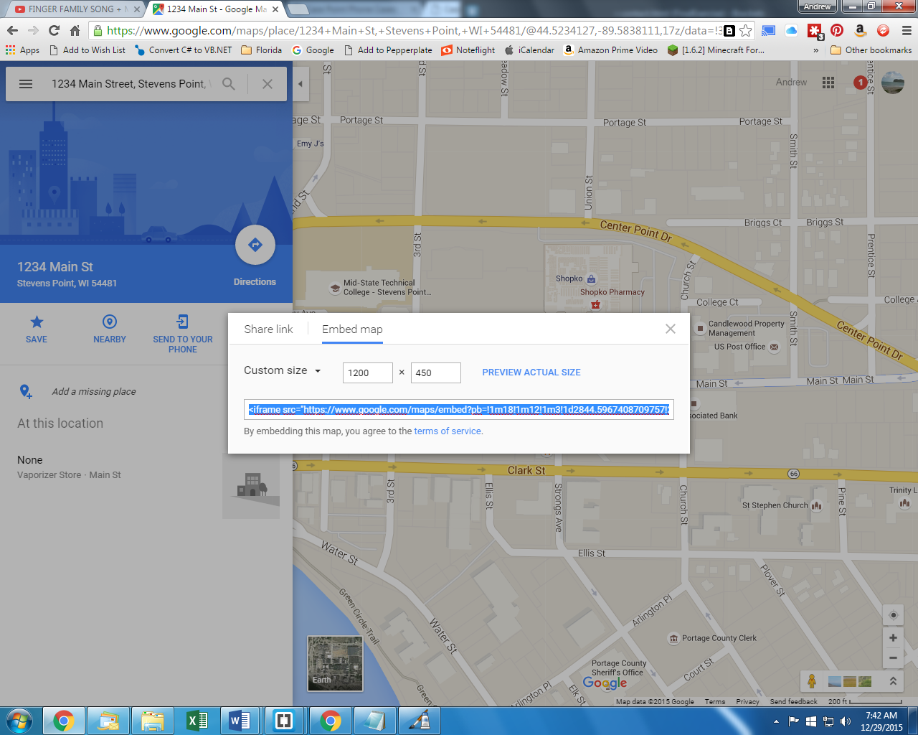
8. Paste the HTML right after the **</h3>** tag.
9. In the HTML you pasted in, there will be a **width="1200"** attribute. Change that to **width="100%"**, so that the map resizes to be responsive.
10. Preview your page to make sure everything appears correctly. Try to fill out the form and click Submit.   
      
    What happens? _____________________________________________  
      
    This is a “poor man’s” form – most web sites use programs that run on the server to parse and respond to user input. But that’s beyond the scope of this course.

# Exercise 8 - Carousels

1. Copy your **Exercise7** folder to a new folder called **Exercise8**.
2. Open Brackets.
3. Go under the **File** menu to **Open Folder**. Choose the **Exercise8** folder.

## Add a Carousel

1. Go to <http://getbootstrap.com/>
2. Click on the JavaScript link in the navigation bar.
3. Click on the Carousel link on the right-hand side of the page.
4. Copy the example HTML.
5. Open the **index.html** page.
6. Right after the **</nav>** tag:
   1. Delete the **talking-on-phone-resized.jpg <img>** element.
   2. Paste the carousel HTML.
   3. Delete all of the …s
7. Go under the **Find** menu to **Replace**.
8. Replace all **carousel-example-generic** with **carousel-main**.
9. Find the **<div class="carousel-inner" role="listbox">** element. Each **<div class="item">** within is a separate slide for the carousel.
   1. Find the first **<img>** element, and change the **src** attribute to point to the **talking-on-phone-resized.jpg** picture. Change the **alt** attribute to **Talking on phone**.
   2. Find the second **<img>** element, and change the **src** attribute to point to the **iphone-in-water-resized.jpg** picture. Change the **alt** attribute to **iPhone dropped in water**.
   3. Duplicate the second **<div class="item">** element, and all its contents, so that we have a third slide.
   4. Change the third **<img**> element’s **src** attribute to point to the **shattered-phone-screen-resized.jpg**, and change the **alt** attribute to **Shattered phone screen**.
10. Preview your page. The carousel should automatically cycle through the three slides, and you should be able to click on the arrows to manually move the slides. But the images don’t stretch to fill the full screen anymore. Let’s add some CSS to fix that.
11. Open **site.css**.
12. Add the following style:

.carousel-inner .item img {

max-width:150%;

min-width:100%;

overflow:hidden;

}

1. Preview the page again. That’s better!

## Add Carousel Captions

1. Back in **index.html**, find the first **<div class="carousel-caption">**. Within this element, add:

<h1>phone cases for all models</h1>

<ul class="list-unstyled carousel-list">

<li><span>iPhone 6S</span></li>

<li><span>Samsung Galaxy S6</span></li>

<li><span>And many more...</span></li>

</ul>

1. In the second **<div class="carousel-caption">**, add:

<h1>rugged cases to survive the worst</h1>

<ul class="list-unstyled carousel-list">

<li><span>Otterbox Armor</span></li>

<li><span>Lifeproof FRĒ</span></li>

<li><span>IronMan Armored Metal</span></li>

</ul>

1. In the third **<div class="carousel-caption">**, add:

<h1>protect your investment</h1>

<ul class="list-unstyled carousel-list">

<li><span>Lifetime Warantees</span></li>

<li><span>$1000 Insurance Guarantee</span></li>

<li><span>Friendly Return Policy</span></li>

</ul>

1. Preview your page. It’s hard to read the captions on top of the images because of the colors. Let’s fix that with some more CSS.
2. Open **site.css**. We’re doing some pretty complex styles here – don’t worry if you don’t understand them all. Add:

.carousel-caption {

text-align: right;

}

.carousel-caption h1 {

padding: 0 10px 0 0;

font-size: 3em;

color: white;

text-transform: uppercase;

text-shadow: 1px 1px 2px rgba(0,0,0,0.5);

line-height: 1.4em;

background-image: linear-gradient(rgba(136,193,73,0.8), rgba(115,168,57,0.8) 60%, rgba(105,153,52,0.8));

}

.carousel-caption h1 a {

color:white;

text-decoration:none;

}

.carousel-list {

top: 60px;

margin: 0 auto;

}

.carousel-list li {

color: #fff;

font-size: 2em;

margin-bottom: 10px;

overflow: hidden;

text-transform: uppercase;

}

.carousel-list li span {

background-color: rgba(0,0,0,0.4);

padding: 18px;

}

1. Preview your page. The captions look much better! Shrink your browser down to be phone-sized. Now the captions aren’t all visible! More CSS to the rescue! Add the following to your **site.css**:

/*small*/

@media (max-width:991px) {

.carousel-caption h1 {

font-size: 2em;

}

.carousel-list li {

font-size: 1.6em;

line-height: 1.6em;

}

.carousel-list li span {

padding: 5px;

}

}

/*phone*/

@media (max-width:550px) {

.carousel-caption h1 {

font-size: 1em;

}

.carousel-list li {

font-size: 1em;

line-height: 1em;

}

}

1. Preview your page again. The captions now shrink down when the page gets narrower.

## Add Other Captions

Now that we have some styles for the carousel captions defined, we can re-use those styles to put captions on top of some of the other images we put on our site.

1. Open **index.html**.
2. Find the **<img>** element with the **girl-with-triangle-phone-case.jpg**. We’re going to surround the image with HTML elements just like we did for images in the carousel.
   1. First, delete the existing **class** attribute from the **<img>**.
   2. Before the **<img>**, add:

<div class="carousel">

<div class="carousel-inner">

<div class="item active">

* 1. After the **<img>**, add:

<div class="carousel-caption">

<h1>Our Best Selling Cases</h1>

</div>

</div>

</div>

</div>

&nbsp;

1. We need to add the “best selling” cases to the home page. Open **products.html**, and find the **<div class="row">** that contains the phone cases.
2. In Brackets, you can click on the triangles in the margin to collapse an element. Click on the triangle in the margin to collapse this div.

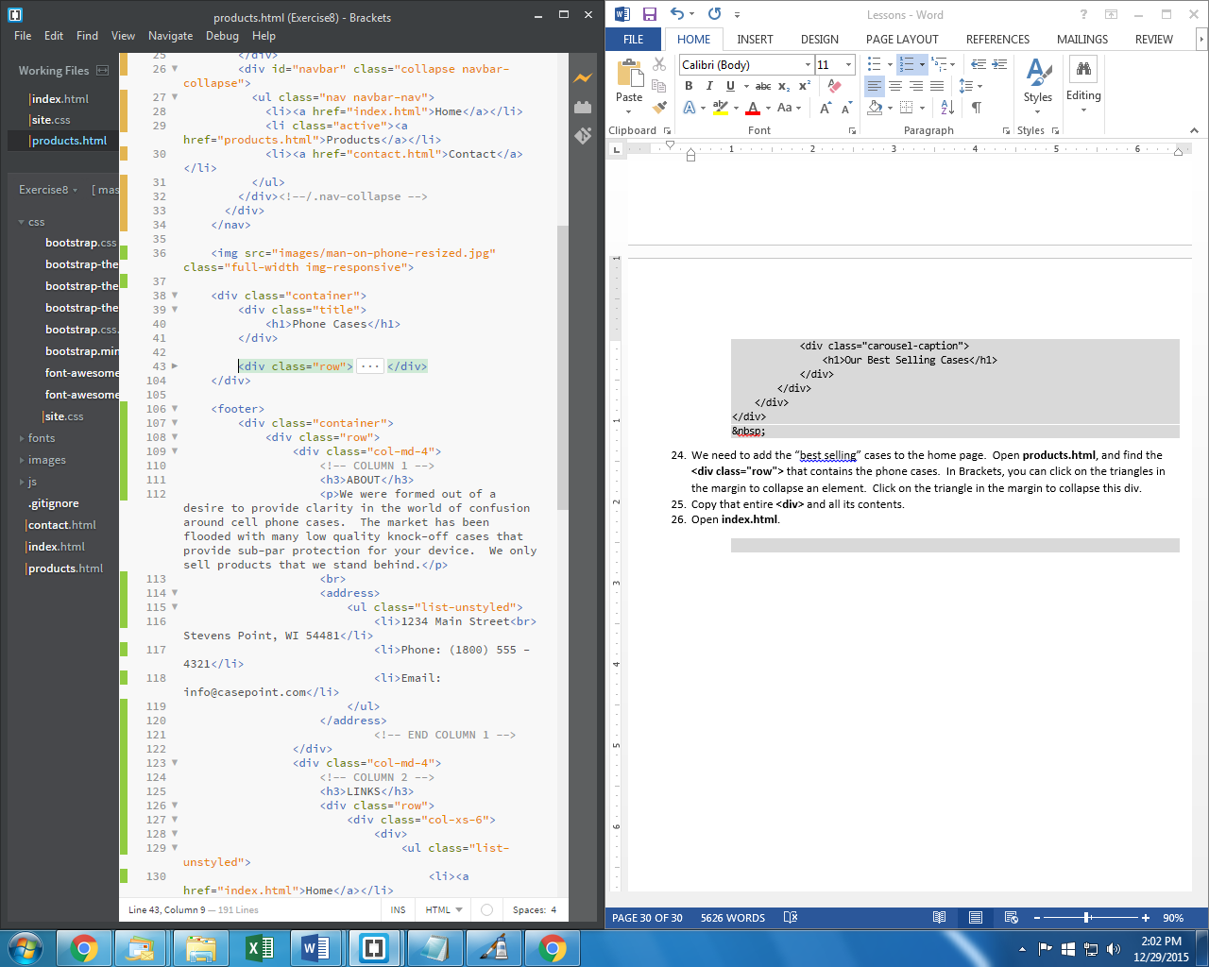

1. Copy the entire collapsed line. This will copy the **<div>** element and everything inside it.
2. Open **index.html**.
3. After the **&nbsp;** we just added, paste the HTML you just copied.
4. Open **products.html**.
5. Find the **<img>** element with the **man-on-phone-resized.jpg**. We’re going to surround the image with HTML elements just like we did for images in the carousel.
   1. First, delete the existing **class** attribute from the **<img>**.
   2. Before the **<img>**, add:

<div class="carousel">

<div class="carousel-inner">

<div class="item active">

* 1. After the **<img>**, add:

<div class="carousel-caption">

<h1>Our Products</h1>

</div>

</div>

</div>

</div>

# Exercise 9 – Animations

Time to add some whiz-bang to our site! We can do this by adding one more external library, specifically for animations.

1. Copy your **Exercise8** folder to a new folder called **Exercise9**.
2. Open Brackets.
3. Go under the **File** menu to **Open Folder**. Choose the **Exercise9** folder.
4. Go to <https://daneden.github.io/animate.css>
5. Look through the drop-down of all the different animation styles you can do. Pick two that you like and make a note of their names:  
     
   ___________________________________ ___________________________________
6. Right-click (Ctrl+Click on a Mac) on the text that appears, and go to **Save As**. Save the file in your **Exercise9** folder, inside the **css** folder.
7. Open **index.html**. Near the top of the file, add a **<link>** to the new **animate.css** right before the **<link>** to **site.css**.
8. Find the first **<div class="carousel-caption">**. On the **<h1>** element directly after it, add a **class="animated style1"** attribute. Use the first animation style you chose above instead of style1. For example, I used **class="animated fadeInDownBig"**.
9. On each **<li>** below the **<h1>**, add a **class="animated style2"**, substituting the second animation style you chose above instead of style2. For example, I used **class="animated bounceInLeft"**.
10. Repeat the previous two steps for the other two **<div class="carousel-caption">**.
11. Preview your page.
12. Open **site.css**. Add the following styles:

.carousel-list li:nth-child(1) {

animation-delay: .3s;

}

.carousel-list li:nth-child(2) {

animation-delay: .5s;

}

.carousel-list li:nth-child(3) {

animation-delay: .7s;

}

1. Now preview your page. What changed?  
     
   ___________________________________________________________________________
2. We had added a **<div class="carousel-caption">** by the **girl-with-triangle-phone-case-resized.jpg**. Add the animation classes to that **<h1>** also.
3. Open **products.html**.
4. Add the **<link>** to the new **animate.css** right before the **<link>** to **site.css**.
5. We had added a **<div class="carousel-caption">** by the **man-on-phone-resized.jpg**. Add the animation classes to that **<h1>** also.
6. Preview your page. Congratulations! Your site is completely done!

# Final Exercise – Your Own Webpage

Create your own website using Bootstrap.

## Step 1 – Define the Purpose/Goal

The website can be for a real or fictitious company, for a non-profit organization, a blog, a personal site, or anything else – it just must have a clear purpose.

My website will be ___________________________________________________________

## Step 2 – Sketch a Design

Incorporate as much of what we’ve covered in this class as possible. Also, feel free to add additional Bootstrap elements that we didn’t cover.

For inspiration and design ideas, visit these sites:

* <http://getbootstrap.com/getting-started/#examples>
* <http://startbootstrap.com/>
* <https://shapebootstrap.net/free-templates>

Sketch designs of your web pages first.

## Step 3 - Write It

You can start with the finished CasePoint web page, or start from scratch. Use the concepts and lessons from this course to put the site together.

## Step 4 – Test It

Make sure all your links work correctly.

Make sure the web page looks correct in different browsers (Firefox, Chrome, Internet Explorer).

Make sure the web page looks correct at different browser sizes.

We’ll display the finished webpages at the spring festival.